Arbejdsark - Citater om kvantemekanik

Dette arbejdsark er ekstramateriale til artiklen ”Fra kvantefysik til kvantecomputere” fra Aktuel Naturvidenskab nr. 6/2022, som knytter an til Klaus Mølmers foredrag i foredragsserien Offentlige foredrag i Naturvidenskab i efteråret 2022. Klaus Mølmers bog ”Kvantemekanik – Atomernes vilde verden” fra Aarhus Universitetsforlag 2010 er også meget relevant baggrundsmateriale.
Materialet er udarbejdet af projektgruppen på Viborg Katedralskole for Aktuel Naturvidenskab i forbindelse med projektet Brobygning på første række finansieret af Novo Nordisk Fonden.
Materialet kan anvendes i forbindelse med artiklen eller til at indlede en kort snak om kvantemekanik.
Målgruppe: Fysik B/A-niveau
Forudsætninger: Ingen

Til underviser
På de næste sider er der givet 9 citater omkring kvantemekanik.
Man kan vælge at udskrive citaterne på et stykke papir (hver gruppe skal have alle citater), eller man kan lægge citaterne op i en virtuel platform.
Eleverne kan arbejde med citaterne på forskellige måder (gives de på papir så klip dem ud):
- Arrangér citaterne efter, om I har lært noget nyt omkring kvantemekanik.
- Hvilket citat synes I er det bedste (og hvorfor er det netop dette citat I har valgt)?
- Arrangér citaterne efter, om I forstår, hvad der menes med dem i forhold til kvantemekanik.

Citater
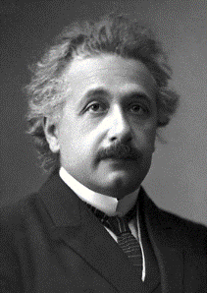
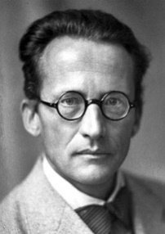
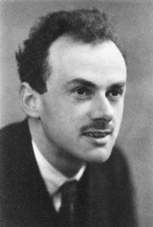
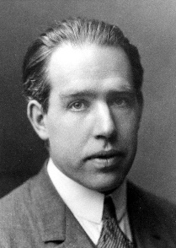
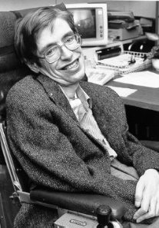
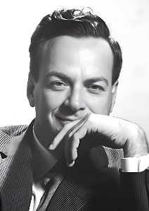
Erwin Schrödinger
Paul Dirac
Niels Bohr
Albert Einstein
Stephen Hawking
Richard Feymann

Citat 1
”Nature isn’t classical, dammit, and if you want to make a simulation of nature, you’d better make it quantum mechanical, and by golly it’s a wonderful problem, because it doesn’t look so easy.”
Richard Feynman 1981
https://aktuelnaturvidenskab.dk/fileadmin/Aktuel_Naturvidenskab/nr-6/AN6-2022-kvantefysik.pdf

Citat 2
"I think I can safely say that nobody today understands quantum mechanics"
R.P. Feynman: "The Character of Physical Law", MIT Press, Cambridge, Mass. (1965)

Citat 3
“You know how it always is, every new idea, it takes a generation or two until it becomes obvious that there’s no real problem. I cannot define the real problem, therefore I suspect there’s no real problem, but I’m not sure there’s no real problem”.
Feynman R. P. Simulating physics with computers, Int. J. Theor. Phys. 21, 471 (1982).

Citat 4
”He [God] does not play dice.”
Albert Einstein, 1926: The Born-Einstein Letters, ISBN 0802703267

Citat 5
“…It seems Einstein was doubly wrong when he said, God does not play dice. Not only does God play dice, but He sometimes confuses us by throwing them where they can’t be seen.”
S. Hawking 1999: https://www.hawking.org.uk/in-words/lectures/does-god-play-dice

Citat 6
“If quantum mechanics hasn’t profoundly shocked you, you haven’t understood it yet.”
Niels Bohr
https://escholarship.org/content/qt7089f729/qt7089f729.pdf

Citat 7
“I have observed in teaching quantum mechanics, and also in learning it, that students go through an experience.... The student begins by learning the tricks of the trade. He learns how to make calculations in quantum mechanics and get the right answers.....it is comparatively painless. The second stage comes when the student begins to worry because he does not understand what he has been doing. He worries because he has no clear physical picture in his head..... Then, unexpectedly, the third stage begins. The student suddenly says to himself, I understand quantum mechanics, or rather he says, I understand now that there isn’t anything to be understood..... The duration and severity of the second stage are decreasing as the years go by. Each new generation of students learns quantum mechanics more easily than their teachers learned it.....”
Paul Dirac
https://arxiv.org/pdf/1604.02589.pdf

Citat 8
“Consequently, we are at this stage still free to choose whether we want to draw conclusions either about the energy of the photon or about the moment when it left the box. Without in any way interfering with the photon between its escape and its later interaction with other suitable measuring instruments, we are, thus, able to make accurate predictions pertaining either to the moment of its arrival or to the amount of energy liberated by its absorption. Since, however, according to the quantum-mechanical formalism, the specification of the state of an isolated particle cannot involve both a well-defined connection with the time scale and an accurate fixation of the energy, it might thus appear as if this formalism did not offer the means of an adequate description. “
N. Bohr 1949
Niels Bohr and Complementarity – An Introduction, Arkady Plotnitsky 2013

Citat 9
“When two systems, of which we know the states by their respective representatives, enter into temporary physical interaction due to known forces between them, and when after a time of mutual influence the systems separate again, then they can no longer be described in the same way as before, viz. by endowing each of them with a representative of its own. I would not call that one but rather the characteristic trait of quantum mechanics, the one that enforces its entire departure from classical lines of thought. By the interaction the two representatives (or $ψ$-functions) have become entangled.”
E. Schrödinger “Discussion of Probability Relations between Separated Systems”
Mathematical Proceedings of the Cambridge Philosophical Society / Volume 31 / Issue 04 / October 1935, pp 555 563 DOI: 10.1017/S0305004100013554, Published online: 24 October 2008

Citat 10
“I admit, of course, that there is a considerable amount of validity in the statistical approach. . . I cannot seriously believe in it because the theory cannot be reconciled with the idea that physics should represent a reality in time and space free from spooky actions at a distance.”
A Einstein, 1947, The Born Einstein Letters, pages 157-159 (Macmillan, London (1971))
(ifølge https://arxiv.org/pdf/2011.08286.pdf )

